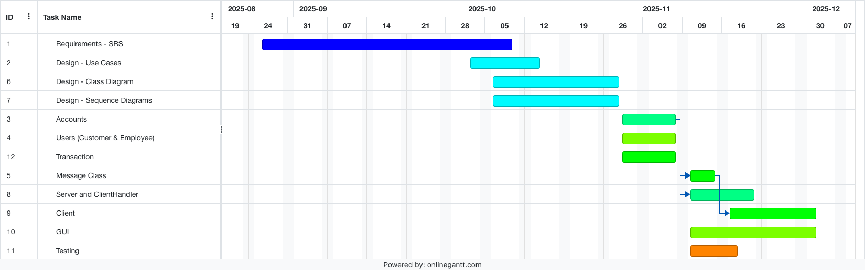
Project Schedule

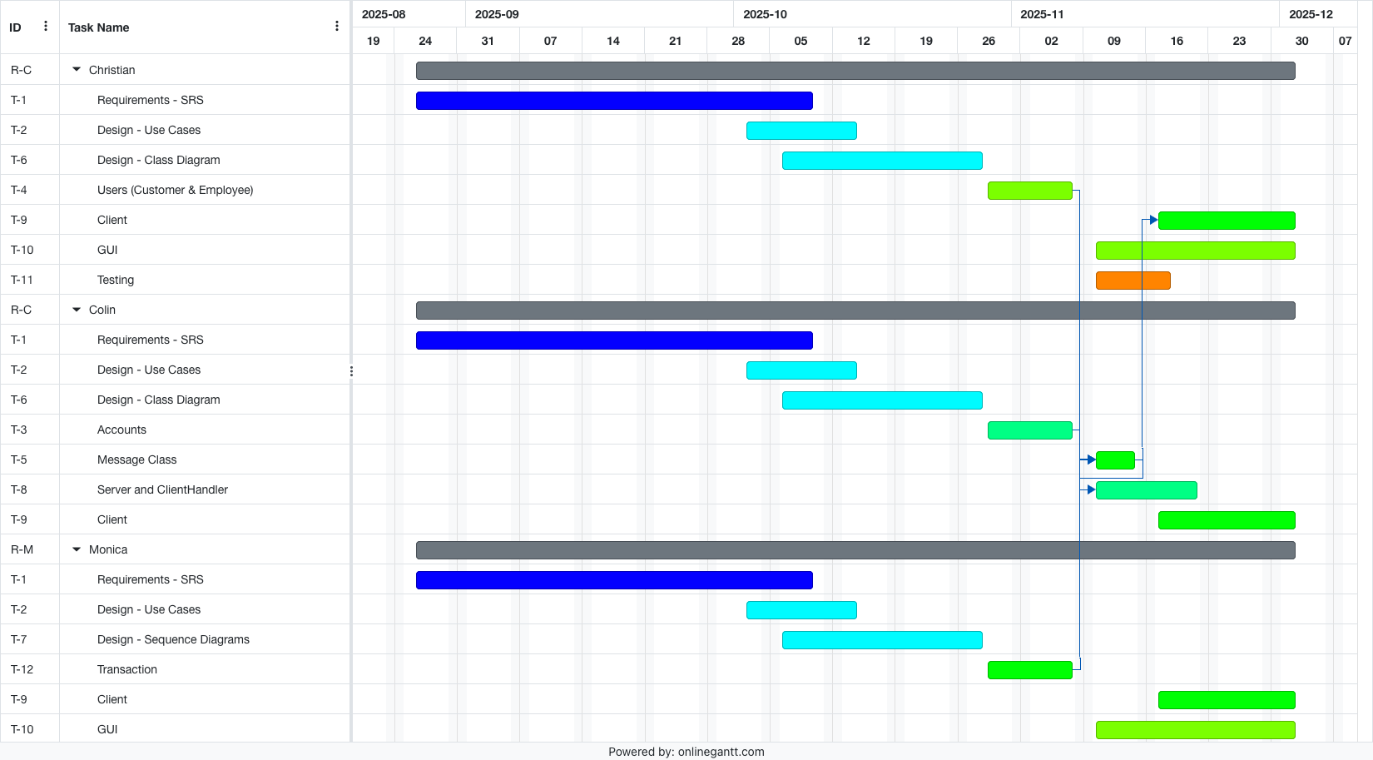
Resource Schedule

